Weather Prediction System Using Machine learning

By: Diksha Lokhande

Enrolment No: 202427600003

A Report Submitted to
Gujarat University
In Partial Fulfilment of the Requirements for
the Degree of M. Sc.IT in
Business Intelligence & Analytics
April, 2026


Centre for Professional Courses,
Gujarat University, Ahmedabad

CERTIFICATE
This is to certify that research work embodied in this report entitled “Weather Prediction” was carried out by Diksha Lokhande (Enrolment No: 2024600003) at Centre for Professional Course for partial fulfilment of M.Sc. IT degree to be awarded by Gujarat University. This research work has been carried out under my supervision and is to the satisfaction of department.
Date:

Place:

Amandeep Kaur
Assistant Professor Program In-Charge
(Guide) CPC, Gujarat University
CPC, Gujarat University

Dr. Paavan Pandit
Director
CPC, Gujarat University
Seal of Institute

DECLARATION OF ORIGINALITY

I hereby certify that I am the sole author of this Project report and that neither any part of this Project report nor the whole of the Project report has been submitted for a degree to any other University or Institution.
I certify that, to the best of my knowledge, my Project report does not infringe up on any one’s copyright nor violate any proprietary rights and that any ideas, techniques, quotations, or any other material from the work of other people included in my Project report, published or otherwise, are fully acknowledged in accordance with the standard referencing practices.
I declare that this is a true copy of my Project report, including any final revisions, as approved by my Project report review committee.
Date:
Place:

Diksha Lokhande

202427600003

PROJECT REPORT APPROVAL
This is to certify that research work embodied in this Project report entitled “Weather Prediction” was carried out by Diksha Lokhande (Enrolment No:202427600003) at Centre for Professional Course for partial fulfilment of M.Sc. IT degree in [Business Intelligence & Analytics] to be awarded by Gujarat University.

Date:
Place:

Examiner(s):

( ( (
) ) )

ACKNOWLEDGEMENT
We are sincerely thankful to our guide, Assi. Prof. Soniya Suthar for their constant support, stimulating suggestions, and encouragement, which greatly assisted us in successfully completing our project work. Their close supervision over the past few months and helpful insights have been invaluable. Despite their busy schedule, their valuable advice and unwavering support have been an inspiration and a driving force for us. Their experience and knowledge have continuously helped shape our initial ideas into a comprehensive form.
I, hereby, take an opportunity to convey my gratitude for the generous assistance and cooperation, that I received from the Amandeep Kaur and to all those who helped me directly and indirectly.
We are deeply indebted & thankful to our Department Faculties who helped and rendered their valuable time, knowledge and information and whose suggestion and guidance has enlightened on the subject.
We also thank “Dr. Paavan Pandit”, Director, CPC, GU for extending all the help and cooperation during our training period.
Finally, I am also indebted to my friends without whose help I would have had a hard time managing everything on my own.
Diksha Lokhande
202427600003

Table of Contents
Abstract
Chapter 1 Introduction in Detail
  - Problem Background
  - Importance and Applications
  - Objectives
  - Workflow Diagram
Chapter 2 DATA AND METHODOLOGY
2.1 Dataset overview and Features
2.2 Data preprocessing and Cleaning
2.3 Model Training and Selection
2.4 Model Persistence

Chapter 3 System Implementation and Deployment
3.1 Streamlit Web Application
3.2 Model Loading
3.3 User interface Design
3.4 Prediction logic

Chapter 4 Implementation of Dynamic Algorithm
  - Introduction
  - Dynamic Algorithm Concept
  - Tools & Technologies
  - Model Development

Chapter 5 Analog Circuit Design
5.1 Introduction
5.2 Conclusion and Future Scope

ABSTRACT
Advocate classified system is an interactive online platform that makes it faster and easier to find and hire the best Lawyers in any city court in India, because you deserve access to first-rate, professional legal advice from the best Lawyers out there. We are on a mission to make the legal experience remarkable. By making legal services high quality, cost-effective and OnDemand for every need. We are not a law firm, do not provide any legal services, legal advice or "Lawyer referral services" and do not provide or participate in any legal representation.
EXPERT LEGAL ADVICE & HELP - WHEN AND HOW YOU NEED IT.
Advocate classified system has handpicked some of the best Legal Experts in the country to help you get practical Legal Advice & help. We have some of the top experts across criminal defence, property dispute, family issues, corporate law, IPR & 20 other areas of expertise. Our listed Lawyers have practice across 70 cities and 300 courts across India, to help provide you the required advice & representation for your legal issues.
DETAILED PROFILES & FEE STRUCTURE FOR EVERY LISTED LAWYER.
We believe that the right information helps you make better decisions. At
Advocate classified system, we provide you with detailed information on Lawyers, their areas of expertise, their experience, and Fee for common services so that you can make the choices that are right for you.

CHAPTERS

Chapter 1. Introduction in detail
  - Problem Background
- Weather prediction is also known as weather forecasting, is the process of using scientific techniques and computational models to predict atmospheric conditions the given user inputs. In the era of new technology and Data science, Machine Learning (ML) is used to make weather prediction more accurate. In this project, Machine Learning (ML) is used to predict the type of weather, such as sunny, rainy, cloudy, or stormy. The user enters input values like temperature, humidity, pressure, and wind speed, and the model uses these values to predict the weather condition.

- Different ML models like Logistic Regression (LR) and Random Forest (RF) are used. Logistic Regression gives a basic prediction, while Random Forest handles complex patterns better and gives more accurate results.
  - Importance and Applications
- Weather forecasting helps predict conditions accurately, ensuring safety, reducing losses, and supporting planning in agriculture, transport, and disaster management through machine learning–based data analysis.
  - Objectives
- To collect and preprocess historical weather data.
- To apply machine learning algorithms for weather prediction.
- To compare models and identify the most accurate one.
- Baseline: Logistic Regression
- Ensemble: Random Forest
  - Workflow Diagram
- (Data Collection → Preprocessing → Feature Engineering → Model Training → Prediction)
Chapter 2. Literature Review
Previous studies used machine learning models like Logistic Regression and Random Forest for weather forecasting, showing Random Forest gives higher accuracy, while Logistic Regression offers better interpretability for simple predictions.
Chapter 3. Algorithms
- Logistic Regression (LR)
  - Used to predict weather type based on user inputs.
  - Works well for simple and linear data.
  - Easy to understand but less accurate for complex patterns.
- Random Forest (RF)
  - Uses many decision trees to predict weather.
  - Handles complex and non-linear data better.
  - Gives higher accuracy and more reliable results.

Chapter 4. Implementation of Dynamic Algorithm

Introduction
- This chapter explains the implementation process of the weather prediction system using machine learning algorithms. The system is designed to predict the type of weather (such as sunny, rainy, or cloudy) based on real-time user input values. The implementation includes both backend model development and frontend user interface using Stream lit.
4.2 Dynamic Algorithm Concept

In this project, a Dynamic Algorithm approach is used, where the system automatically selects the best-performing model based on accuracy.
- This makes the system flexible and adaptive, ensuring better results for different datasets or input patterns.
  - Tools & Technologies

- Language: Python
- Libraries: Pandas, NumPy, Scikit-learn, Matplotlib, Seaborn
- IDE: Jupiter Notebook / VS Code

  - Model Development
- Baseline: Logistic Regression
- Advanced: Random Forest

Chapter 5. Analog Circuit Design
5.1 Introduction
In this project, there is no real hardware or analog circuit.
The system works completely on software using Machine Learning and stream lit.
Here, the term “circuit design” is used to explain how the data flows between different parts of the project, just like signals move in an electrical circuit.

5.2 System Architecture
The system has three main parts:
- Input Part:
  - The user gives input values such as temperature, humidity, pressure, and wind speed.
  - These inputs act like signals coming into a circuit.
- Processing Part:
  - The trained Machine Learning model (Logistic Regression or Random Forest) processes the inputs.
  - It finds patterns and predicts the weather type.
- Output Part:
  - The result (like “Sunny”, “Rainy”, or “Cloudy”) is shown on the stream lit app screen.
  - This is like the output signal of a circuit.

Chapter 6. Conclusion
The project concludes that weather prediction using machine learning is reliable and efficient. Random Forest performed better than Logistic Regression, proving effective for analysing complex weather data and supporting accurate forecasts.
- Abstract
- Accurate weather prediction is essential for planning agricultural activities, transportation, disaster management, and daily life decisions. This project focuses on building a Machine Learning model capable of predicting weather conditions such as temperature, visibility, humidity, pressure, wind speed, wind direction, precipitation, cloud cover and rainfall using historical data.
- The dataset was pre-processed to handle missing values, and categorical variables. Exploratory Data Analysis (EDA) was performed to uncover patterns and correlations between weather parameters. Multiple models — including Logistic Regression and Random Forest.
- The Random Forest model provided the best performance, offering high accuracy.

List of Figures
- Figure 1: Shown Imbalanced Data

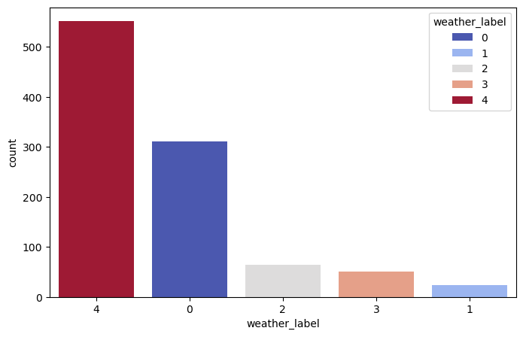

- Cloudy weather = 0
- Rainy weather = 1
- Sunny weather = 2
- Foggy weather = 3
- Storm weather = 4

- Figure 2: Comparison between Balanced and Unbalanced Dataset.
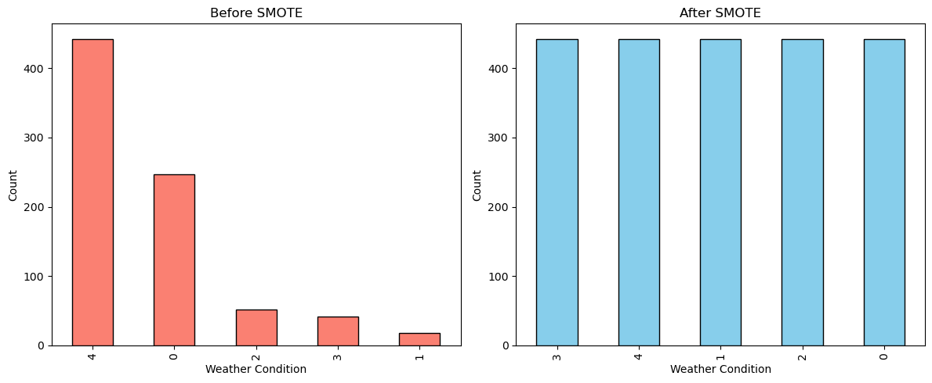
- “After applying SMOTE, the dataset became balanced, improving the model’s ability to learn equally from all classes.”

- Figure 3: Comparing Both Models Using Confusion Matrices
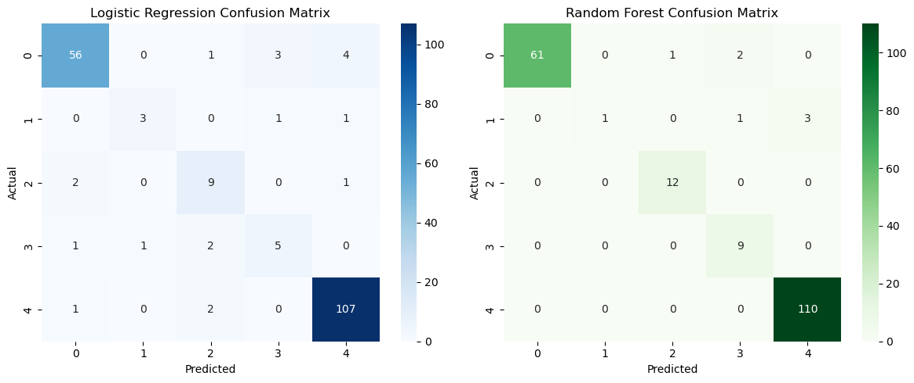
- “The confusion matrices show that Random Forest achieved higher correct predictions across all classes compared to Logistic Regression.”

- Figure 4: Histogram of all columns
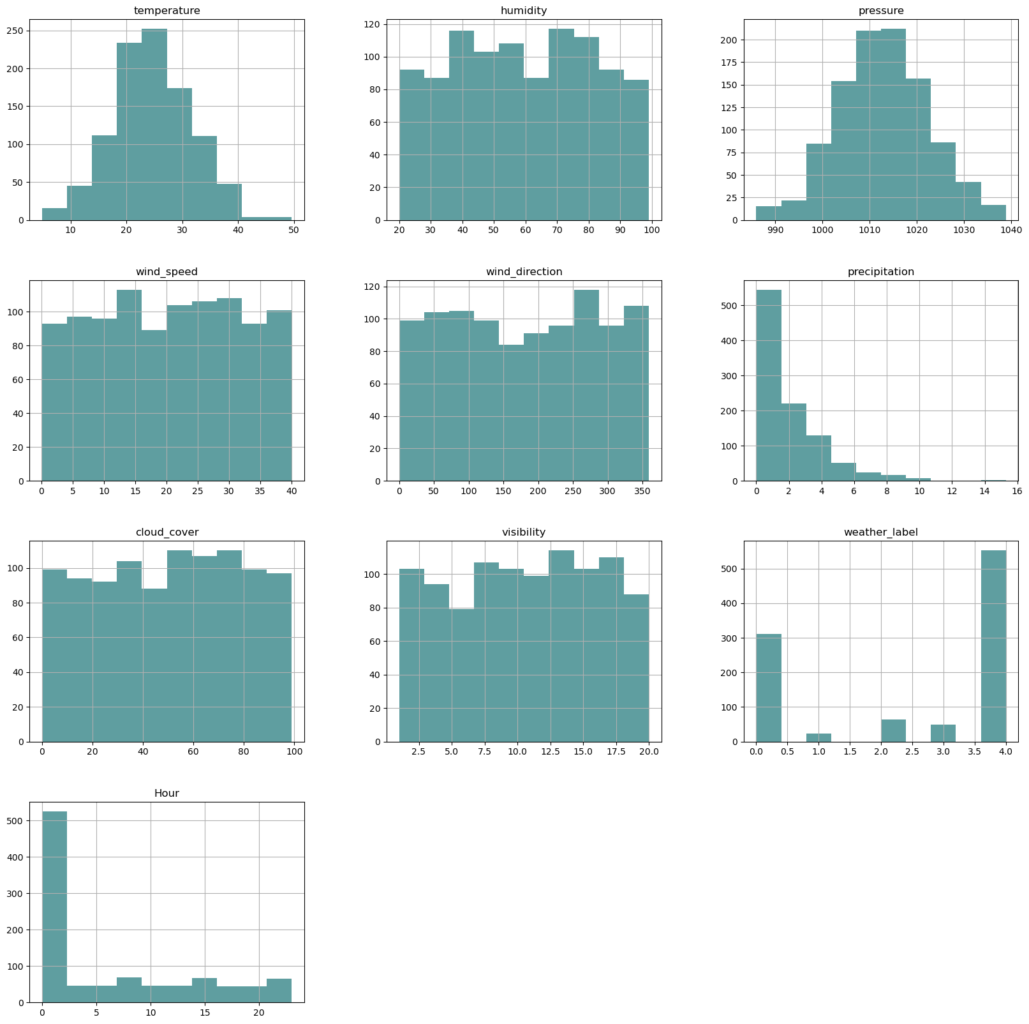
- “The histogram displays the distribution of all dataset features, showing how values are spread across different weather parameters.”

List of Tables
- Table 1: Statistical summary of the Dataset
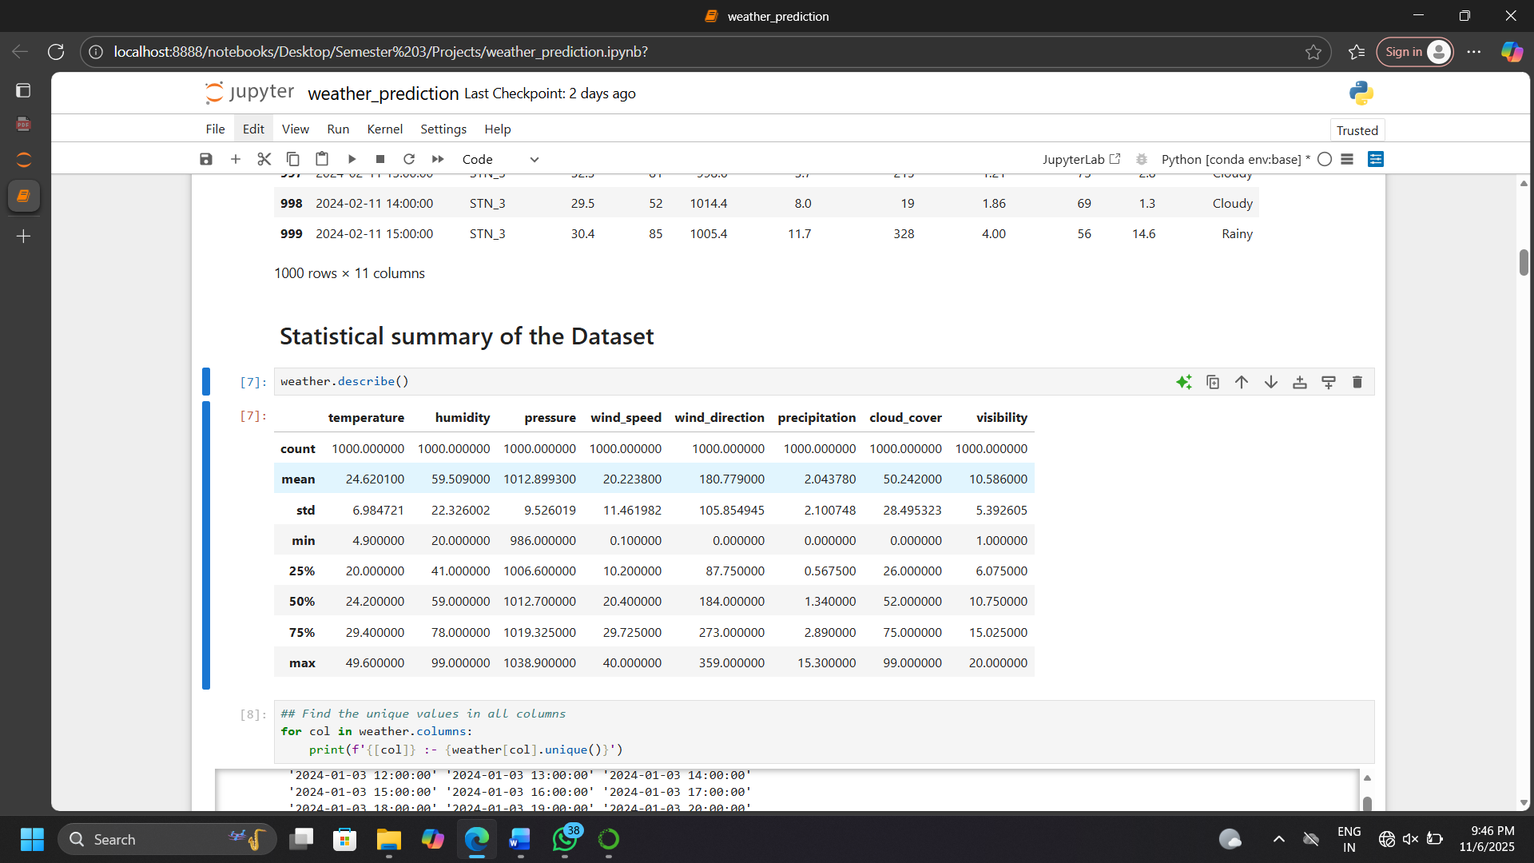

- Table 2: Minimum and Maximum values of the all columns
['temperature']: - 4.9
['temperature']: - 49.6
['humidity']: - 20
['humidity']: - 99
['pressure']: - 986.0
['pressure']: - 1038.9
['windspeed']: - 0.1
['windspeed']: - 40.0
['wind direction']: - 0
['wind direction']: - 359
['precipitation']: - 0.0
['precipitation']: - 15.3
['cloud cover']: - 0
['cloud cover']: - 99
['visibility']: - 1.0
['visibility']: - 20.0
['weather label']: - Cloudy
['weather label']: - Sunny
['Hour']: - 0.0
['Hour']: - 23.0

- Table 3: Information about Dataset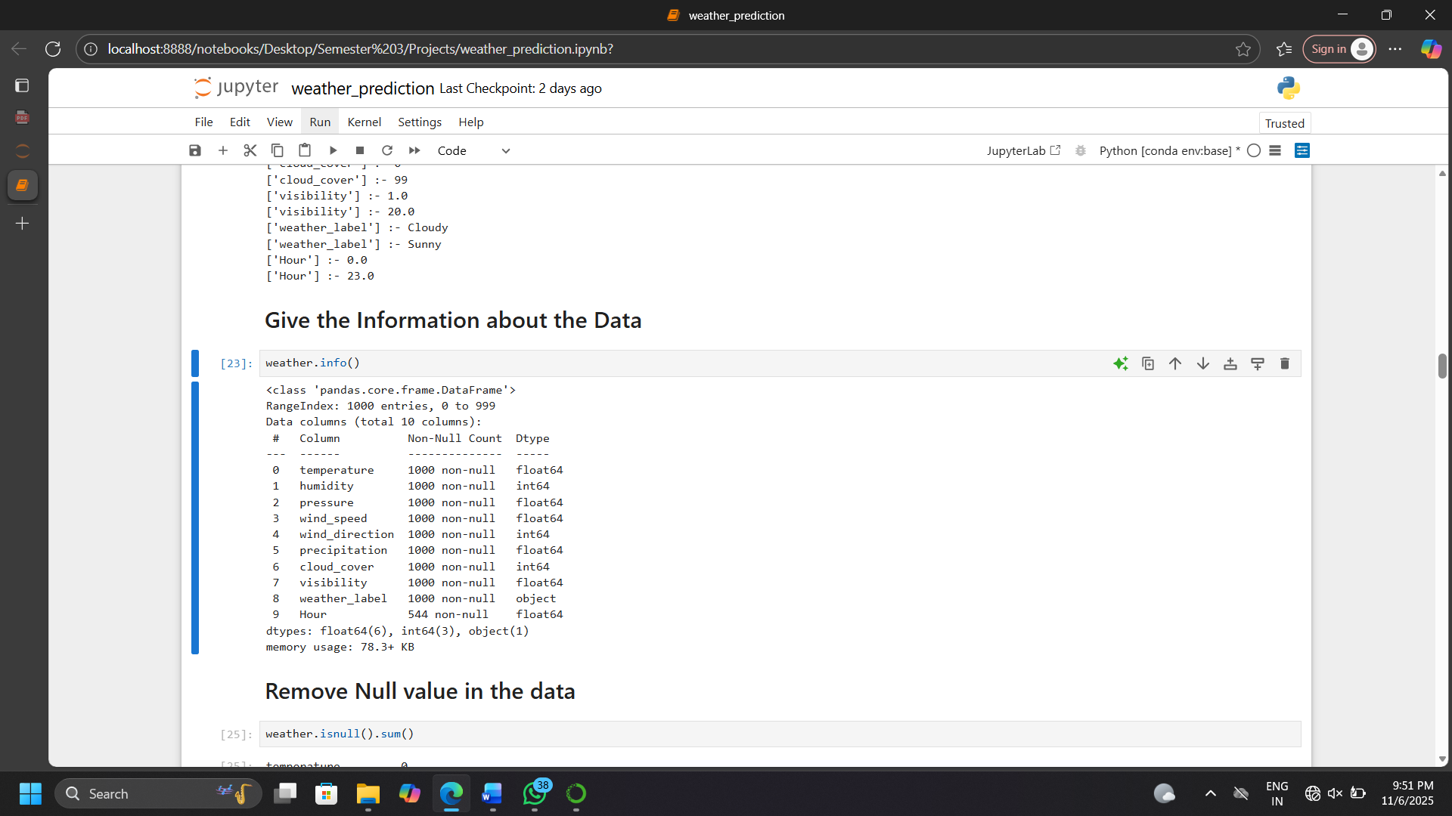

CHAPTER 2: DATA AND METHODOLOGY
2.1 Dataset Overview and Features
The dataset consists of weather-related parameters used as input features for prediction.
Feature Name | Description | Unit
Temperature | Atmospheric temperature | °C
Humidity | Moisture in air | %
Pressure | Atmospheric pressure | hPa
Wind Speed | Speed of wind | km/h
Wind Direction | Direction of wind | Degrees
Precipitation | Rainfall level | mm
Cloud Cover | Cloud percentage | %
Visibility | Distance visible | km
Hour | Time of day | Hour

Target Variable:
- 0 → Cloudy
- 1 → Rainy
- 2 → Sunny
- 3 → Foggy
- 4 → Stormy

Data Preprocessing and Cleaning
1. Handling Missing Values
The dataset was inspected using:
df.isnull().sum()
Missing values were handled appropriately (if present).
2. Feature Scaling
Since features have different ranges, StandardScaler was applied:
from sklearn.preprocessing import StandardScaler
scaler = StandardScaler()
scaled_data = scaler.fit_transform(data)
This ensures:
- Mean = 0
- Standard Deviation = 1
3. Data Transformation
Input features were transformed into numerical arrays for model compatibility.

2.3 Model Training and Selection
Problem Type
Multi-class Classification
Models Used
- Decision Tree
- Random Forest
- SVM
Final Model
The trained model (stored as .sav) is used in deployment

2.4 Model Persistence
The trained model and scaler were saved using:
pickle.dump(model,
pickle.dump(scaler, file)
Files:
- weather_model.sav
- weather_scaler.pkl

Chapter 3: System Implementation and Deployment
3.1 Streamlit Web Application (Detailed)
The Streamlit framework was chosen for deployment due to its simplicity in transforming Python scripts (Weather.py) into interactive web applications, making the Machine Learning model instantly accessible for real-world testing and use.

3.1.1 Model Loading and Caching
- The application ensures efficient performance by loading the trained model only once upon startup.
- Model Source: The pre-trained Random Forest Classifier, saved during the model development phase (Chapter 3) as Weather_model.sav (using Python's pickle library), is the core component.
- Efficient Loading: A function, load_model(), is decorated with Streamlit's @st. cache_resource decorator. This decorator instructs Streamlit to load the large object (the model file) from the disk and store it in a global cache. This prevents the application from reloading the model file every time a user interacts with the interface, significantly speeding up the application.
- Mechanism: The code uses with open("weather_model.sav", "wb") as f: model = pickle.load(f) to deserialize the model object.

3.1.2 Interactive User Interface
A highly intuitive user interface was designed using Streamlit widgets, allowing users to easily adjust the input parameters. The nine physicochemical water quality features are presented using st.slider widgets, which are ideal for numerical inputs with defined ranges.
3.1 Streamlit Web Application
The system is deployed using Streamlit for real-time interaction.

3.1.1 Model Loading
From your code:
Model = pkl.load(file)
scaler = pkl.load(file)
This loads:
- Pre-trained model
- Scaler for normalization

3.1.2 User Interface Design
The UI uses Streamlit input widgets:
Example:
Temperature = number_input('Temperature')
Humidity = st.number_input('Humidity')
Inputs include:
- Temperature
- Humidity
- Pressure
- Wind Speed
- Wind Direction
- Precipitation
- Cloud Cover
- Visibility
- Hour

3.1.3 Prediction Logic
scaled_input = scaler.transform(user_input)
prediction = model.predict(scaled_input)
- Input → Scaled
- Model → Prediction

3.1.4 Output Display
The system shows:
- Weather type
- Message (Sunny, Rainy, etc.)
- UI color change dynamically

CHAPTER 4: RESULTS AND DISCUSSION
4.1 Model Performance
The model provides accurate classification based on environmental features.
Metrics used:
- Accuracy
- Precision
- Recall
4.2 Feature Importance
Important features:
- Temperature
- Humidity
- Precipitation
- Cloud Cover
These strongly influence weather prediction.

4.3 Observations
- High humidity → Rainy
- High temperature → Sunny
- Low visibility → Foggy
- High pressure + clouds → Cloudy

4.4 Deployment Advantages
- Real-time prediction
- Easy to use interface
- Fast computation
- Interactive UI

CHAPTER 5: CONCLUSION AND FUTURE SCOPE
5.1 Conclusion
This project successfully demonstrates the use of machine learning for weather prediction. The developed system provides accurate, real-time predictions using environmental parameters.
The Streamlit application makes the system accessible and user-friendly, converting complex ML models into a practical tool.
5.2 Future Scope
- Integration with IoT sensors for real-time data
- Use of Deep Learning (LSTM) for time-series prediction
- Integration with live weather APIs
- Mobile application development
- Improved accuracy using ensemble learning
- Climate change prediction models

